Religious Conversion

Our review of five USB-to-S/PDIF convertors invokes digital religion, Noel Keywood says.

Rafael Todes listens in supplication.

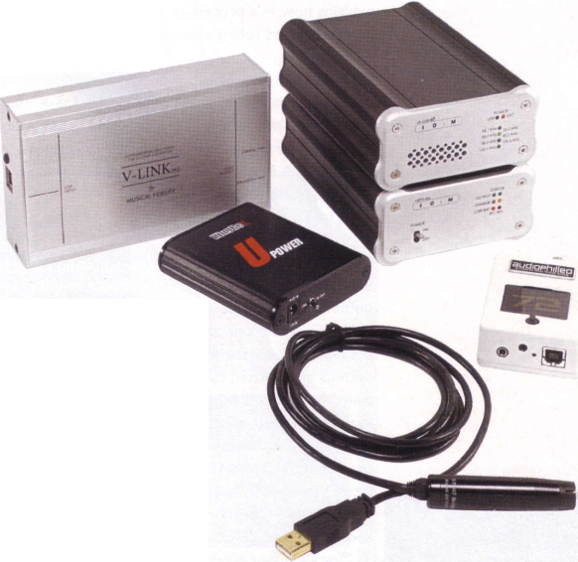
[tltiiUlie
/ar—
□
D
igital can be confusing at the best of times, and this group of unassuming little convertors demonstrates the issue. Superficially, they convert USB digital audio, typically from a computer, to S/PDIF digital audio suitable for a hi-fi.Their role then is simply to allow a computer to connect to the hi-fi, so music can be played from Windows Media player or iTunes through a decent sound system.
Somewhere along the line, this simplest of ideas got diverted into arcane digital complexity.The digital conversion process has been configured so what could have been simple definitely is not: these units don’t just convert, many of them clean up the digital signal too, in order to lift sound quality. Enter religion!
The group comprises five convertors, ranging in price from the Kingrex UC192 at £ 159 up to an eye watering £825 for the Audiophilleo I - and more expensive designs are available. Budget convertors simply do their stated job, convert from USB to S/PDIF, but as price increases a more sophisticated method of clock control, known as asynchronous operation (see page 25) enters the picture, as well as other interesting ideas such as an external USB power supply and - naturally! - a battery powered external USB power supply.
Yes, it all gets nutty quickly, but that’s what happens to digital audio once audiophile religion takes hold. In this review we keep away from the horrors of Phase Locked Loops and suchlike, and keep it simple. In any case, as intelligent as modern digital circuits are now becoming in their attempts to suppress the ills of digital, the local digital signal chain is so complex and behaviourally difficult to predict, that what actually happens in any one set up cannot be fully known by outside observers.
Digital audio as it comes out of a computer’s USB port is in an entirely different format to that concocted for an S/PDIF connection into a hi-fi system. A USB receiver must assemble the computer audio data, retrieve the clock information, and reduce or eliminate blemishes such as jitter and noise. It is possible to clean up a digital signal using a variety of strategies, often one after another in a daisy chain of digital signal processing, before sending it out to the hi-fi, and both the degree and the sophistication of these strategies is what decides cost.
Whilst most convertors use function-specific silicon chip building blocks, this has difficulties, especially with computer compatibility.Two models, the Halide Bridge and Audiophilleo, use non-function- specific Digital Signal Processors (DSP) in conjunction with an audio framework code, as well as their own custom code, to perform the process and both linked up to Windows Vista (SP2) and Windows 7 immediately in our tests (we did not try XP etc). With the others, a special Windows driver is needed, supplied by the manufacturer. Listening was carried out on Windows 7.
Mac OS-X from 10.6 (Snow Leopard) onward works with its own drivers that can handle asynchronous operation.Tests were carried out using OS-X 10.6, so both Windows and Mac were used to check for compatibility.

LISTENING
The way digital can degrade sound quality is well known to Rafael Todes, as it affects his recordings of the
Alegri String Quartet, in which he plays an Amati violin. In particular, loss of spacial perspectives blurs the placement of players, loss of timbral resolution lessens differences between brass and woodwind, making his Amati sound like a Yamaha synth copy, and digital glare or hardness makes gut strings sound like steel ones.These are all sensitive issues for him so he was keen to listen to these convertors, feeding his Weiss DAC202, a Music First Audio passive preamp, and B&W 802D loudspeakers. Recordings were various but included his own of the Alegri. He listened before we measured and the correlation between what he heard and what we measured is surprising.
* see p25 for Conclusion, computer compatibility, asynchronous operation, tests and much more.

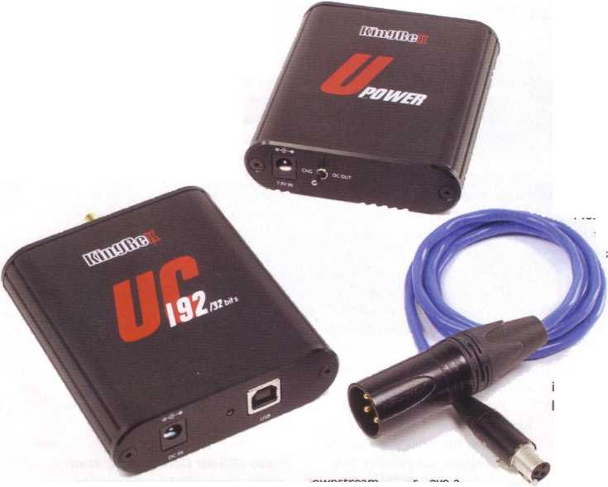
KINGREX UC192 £159

USP: Optional battery power supply, entry level 32/192
capable converter with proprietary USB drivers. Adaptive.

K
ingrex say “the UC 192 can transfer from PC or Mac at 16bit, 44.1 kHz to 32bit, 192kHz through S/ PDIF and I2S outputs.The UC 192 runs isochronous
of an I2S output via an RJ45 socket. This is an internal link, where clock and data are carried separately (there is no agreed socketry for it). It is preferable to S/PDIF but few

SOUND QUALITY
Listening to the 'Dance of the Tumblers' shows a good presentation, up there with the others.There seems to be a touch more sheen to the sound, not unpleasant, just a bit
with an adaptive clock generator to auto sync with the host. The master clock generator is a classy I ppm TXCO unit with proprietary low- jitter drivers for Windows and Mac. Direct Sound, ASIO4ALL, and WASAPI are all supported and run smoothly”. The UCI92 ships with
‘varnished’.The bass is a tad slower than the Halide Bridge and there is just a fraction less air to the sound. I have to mention at this point, that using jPlay in JRiver yielded the blue screen of death to my Windows 7 laptop, and I had to use the fallback of Foobar, which coped well. Not a level playing field, but JPlay doesn’t integrate with every convertor at present. When I try and listen to the
Mozart on Foobar, there seems to be a problem with the awkward sample rate of 88.2, and Foobar doesn’t pick this up, so an exact comparison, like-with-like is impossible.
In the Mozart Prague opening. I’m aware of an issue in the Snow Maiden dance, of a looser bass operating - a bit splashy.

a Windows driver (ASIO4ALL) that needs to be installed on your
downstream DACs have a suitable input - and none from Kingrex, which is peculiar.
Kingrex advise manual driver

The convertor (top) has a mini XLR balanced output at left, plus I2S through an RJ45 socket at right.
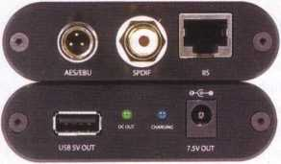
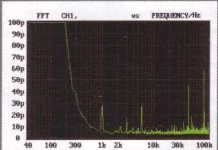
computer and the Kingrex manual explains how, in a procedure that will have Mac users rolling around the floor laughing.
The unit is not USB powered like many, so a USB power supply upgrade will not help. It has its own small wall wart supply, delivering 7.5V
MEASURED PERFORMANCE
The Kingrex result was dominated by appalling clock drift, no less than 7nS, seen at left in our jitter analysis. This is at least x20 more than expected from any digital source, including CD. Using the external battery supply and / or the AES/EBU balanced connection made no difference. Otherwise, signal related and random jitter figures were reasonably low, the balanced connection showing slight improvement over unbalanced.
Recording sample rate 44.1/Output sample rate 48k
clock drift 7nS
signal related 40pS
random 5pS
JITTER
OMGREXUC192 £159
Kagrex
www.kingrex.com
at 200mA. A battery version is available however.
The UC 192 works right up to 24/192 so will handle top resolution digital audio. Balanced and unbalanced S/PDIF outputs are fitted, electrical only; there is no optical output. However, the electrical outputs are isolated by pulse transformers to break hum loops and reduce electrical noise.Transformers need correct termination to minimise jitter; the mini-XLR output must see I IO Ohm termination and unbalanced 75 Ohm.
Very unusual is provision

installation before connection to a computer to prevent Windows automatically installing an unsuitable driver. Kingrex recommend Windows 7 and Mac OS-X 10.6 (Snow Leopard) or later, but older OSes will work, including XP.
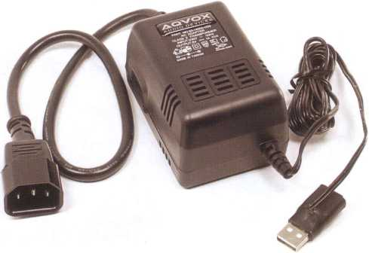
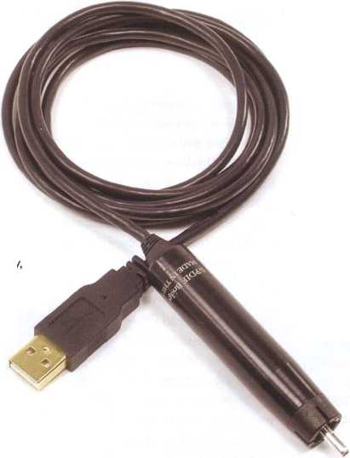
AQVOX USB POWER SUPPLY
This USB power unit supplies 5V at IA to a USB line by breaking the power connection from the computer and inserting itself with an in-line adaptor plug - a neat idea. Rafael used it with the Halide Bridge convertor and felt they worked well together.

SOUND QUALITY
After a cursory survey of the different adapters concerned, I was immediately drawn to this unusual audio piece. It is literally a cable, with the electronics built into the cable - the S/PDIF end. It takes it’s power from the USB on the laptop, but can be cleverly upgraded by providing dedicated power.
Listening to the Linn Records’ version of Mozart’s Prague Symphony conducted by the late Sir Charles Mackerras, I was blown away by the smoothness of the sound, combined with a fulsome and rich quality, which imaged beautifully. The use of the optional dedicated power supply further enhanced this most luxurious of sounds. The link seemed to have a natural sense of authority with this large
The Halide Bridge convertor has a standard USB plug at one end, and a giant phono plug at the other, that plugs into a normal S/PDIF electrical input. Inside the plug lies the convertor.

HALIDE BRIDGE £329

USP: Integral cabling and Wavelength 24/96 asynchronous DSP code that makes Windows drivers unnecessary.
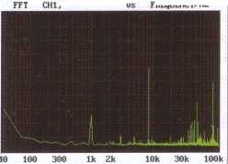
This is a compact and very easy to use convertor that runs Streamlength USB code from Wavelength Audio to interface with Windows Vista and 7, or Mac OS-X asynchronously. As Wavelength Audio seem to specialise in valve amplifiers, alongside USB products, this is a company with a broad outlook.The Halide runs up to 24/96kHz bit depth/sample rate and is USB powered. It can be used with a USB power supply. In Windows and Mac the device must be selected as usual, to get sound through it, but special drivers do not have to be loaded.
orchestra.The basses roared with the right amount of grip and grunt, with no noticeable overhang. The violins sounded very natural, big scale, but never shrieking. Listening to Rimsky Korsakov’s 'Dance of the Tumblers' on Chesky HD tracks, there is superb separation of the orchestral sections, lovely clean tambourine shakings and an overall sound that is airy, but with control.This is up with some of the best servers I have heard, and I am surprised to be getting these results from a humble Toshiba Windows 7 laptop!

MEASURED PERFORMANCE
The Halide Bridge managed very low jitter figures right across the board from our 48k sample rate test. Clock drift was a low 30pS and signal related jitter 25pS, our analysis shows.
Signal related jitter fell to just 10pS from a 44.1 CD track un-resampled, from the Mac. Clock drift sunk to 25pS and these figures were almost as good as it gets with digital.
These are consistently good results, suggesting the Halide Bridge withstands whatever is thrown at it very well, making it a robust convertor.
Recording sample rate 44.1/Output
sample rate 48k clock drift signal related random
JITTER
30pS
25pS
5pS
HALIDE BRIDGE £329
Halidedesign
www.halidedesign.com

MUSICAL FIDELITY V-LINK 24/192 £230

USP: Asynchronous 24/192 converter, USB powered, with supplied Windows driver software.

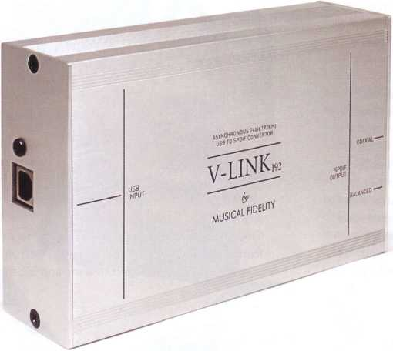

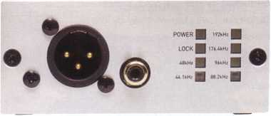
Musical Fidelity keep it simple with balanced XLR output (left) and unbalanced phono only. Bright coloured leds show data rate.
T
he V-Link 24/192 is a straightforward asynchronous convertor that covers all sampling rates up to 192kHz, at up to 24bit resolution. It simply has a USB B plug input at one end, like the others, and electrical outputs at the other, in unbalanced form via a phono socket and balanced form via an XLR. socket.There is no optical output and no power supply; it is USB powered. An array of bright indicators show sampling rate.This is a plug-and-play unit, but for Windows it needs the ASIO USB driver ASIO4AII to be installed, for up to 24/192. With Mac OS-X 10.6 (Snow Leopard) and onward it works fine up to 24/96
of the gaps between the players, and seemed to create a blacker background from which the music emerges. Although it is £70 cheaper than the Halide Bridge, I missed that beautiful sense of calm the Halide created, the way in which it separated orchestral textures so convincingly. The Musical Fidelity seemed to get excited about everything that it reproduced, and in the process I missed the subtlety of texture that the Halide was doing so well, even when both were operating on Foobar.
MUSICAL FIDELITY
V-LINK 24/192 £230
Musical Fidelity www.musicalfidelity.com
only, a limitation imposed by Core Audio in the Mac.

SOUND QUALITY
This convertor presented a slightly bigger soundstage than the others, and seemed to be fuller to the point of shouting the music at me! It seemed to be louder than the other convertors which seems impossible given the job it’s doing. It certainly is a forceful communicator!
I tried a little experiment, fitting the USB power supply to the cable, and this gave me more of a mental picture

MEASURED PERFORMANCE
The Musical Fidelity V-Link delivered a
sample rate 48k
good set of jitter figures from our 44.1k clock drift
sample rate CD test un-resampled. However, when resampled to 48kHz by
the Mac, clock drift rocketed from 20pS to 160pS - no disaster by any means and roughly what is expected from CD players, but not up with the best here.
I Also, a small 30pS jitter peak at 220Hz consistently appeared, not seen on the other devices. These were minor blemishes though and the V-Link still returned good figures.
Recording sample rate 44.1/0utput
signal related random
JITTER
160pS
35pS
5pS
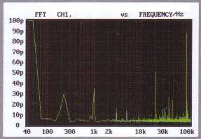

SOTM DX £365

Asynchronous 24/192 converter with supplied Windows driver software and optional battery/mains power supply.

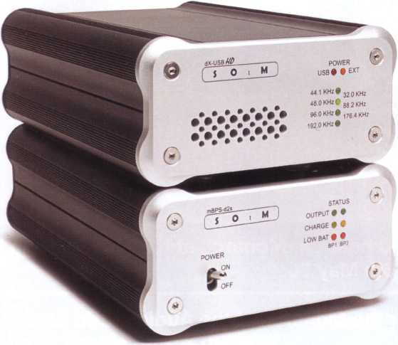


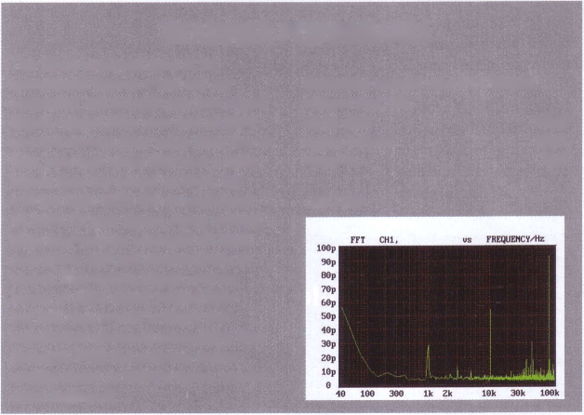
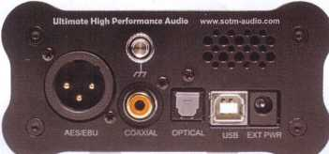
supply, but not as good
MEASURED PERFORMANCE
JITTER
Recording sample rate sample rate 48k clock drift signal related random
The SOtM produced good if not exceptional figures when fed our resampled 48k sample rate test signal. Signal related jitter was low at 30pS and the random jitter noise floor low at 6pS. Low rate clock drift was a little higher than the others at 60pS, but still not high. With the un-resampled 44.1kHz CD test signal, signal related jitter improved as expected to 25pS, with clock drift and random jitter as before. The optical output was no sinner at 38pS signal related jitter but XLR was worse at 50pS; the unbalanced electrical connection was cleanest. With the external power supply, mains or battery mode, results were unaltered.
44.
1/Output
60pS
30pS
6pS
SOTM DX £365
SOtM Audio
www.sotm-audio.com
This is one of the few convertors to have an opti-
cal S/PDIF output. Our measurements showed it
worked almost as well as the electrical outputs,
e awkwardly named SOtM s from Korea. It is an asynchronous convertor that accommodates 44.1 and 48k sample rates and their multiples all the way up to 92kHz, with up to 24bit resolution, so this convertor ticks all the boxes.
- comes with a USB driver disc for A mdows (XP/SP3,Vista/SP2, 7), or ■ work with Mac OS-X 10.6 (Snow
_eopard) onward. Data rate must be set in the Advanced tab of the Sound control panel in Windows.
The small SOtM is USB powered out has an outboard power supply option that alternatively will run it —om batteries instead of the computer’s power supply.The tsatteries are charged from the mains.
S/PDIF outputs are in balanced AES/EBU form via an XLR socket, unbalanced form via electrical output through a phono socket as usual and - unusually - via an optical TOSLINK option as well. On high quality convertors TOSLINK and its need for a transmitter and receiver - potential sources of jitter - is uncommon.

SOUND QUALITY
This two unit affair also shows the importance of taking power seriously.The Chesky download of Rimsky-Korsakov’s 'Dance of the Tumblers' shows that this link has a good sense of control, with good delicacy for the orchestral effects going on.The tambourine starts and stops well, the strings sound clean, perhaps a bit less present than I have
heard on the Weiss playing through FireWire, but a really excellent well- constructed sound with a good solid soundstage. I would put it equal to the Halide Bridge without the extra USB power with the upgrade. It doesn’t quite have the airiness of the Halide, but seems to do the transients superbly.
uincluding AES/EBU at left.

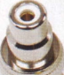
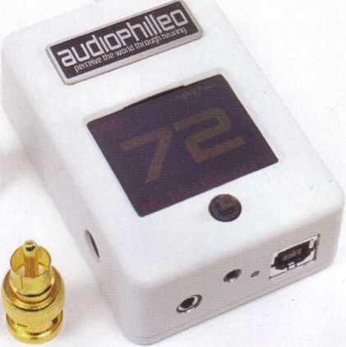
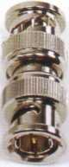

AUDIOPHILLEO I £825

USP: Asynchronous 24/192 converter with its own DSP code that makes Windows drivers unnecessary.
e Audiophilleo is quite radical design, based on a DSP with an audio framework code.The Audiophilleo I is a deep religion convertor that, interestingly, is so complex it is easy to use. Running software that utilises standard Windows and Mac USB drivers it does not need to have a Windows driver loaded, which avoids a lot of hassle. It processes up to 24/192 resolution, working asynchronously.The tiny aluminium case houses not just a DSP but also a full colour OLED display screen, all powered from the USB line. A digital volume control is provided to adjust channel balance by up to lOdB and, for religious education, a jitter generator is fitted so you can learn to
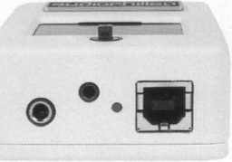
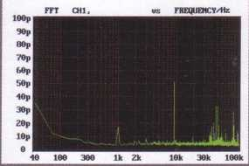
MEASURED PERFORMANCE
The Audiophilleo 1 delivered the best set of figures in the group, just ahead of the Halide Bridge in signal related jitter from our 48k sample rate test signal, returning just 18pS. However, its clock drift was a trifle higher at 35pS, against 30pS for the Halide Bridge. With the less taxing un-resampled CD test signal, clock drift fell to 20pS and signal related jitter to 12pS, incredibly low figures. With the external power supply, signal related jitter sunk to 15pS. Increasing virtual cable from 0 increased signal related jitter slightly, to 35pS max. Switching on jitter produced 4nS of low rate clock drift (non deterministic jitter, not signal related) below 200Hz.
The Audiophilleo was a tiny box with tiny sockets on it, for power, trigger and headphone. It has only USB in and BNC socketed S/PDIF out, for which convertors are provided.
35pS
18pS
5pS
AUDIOPHILLE01 £825
Audiophilleo
www.audiophilleo.com
identify Satan.
As if this wasn’t enough you can also adjust signal rise time, slow for poor cables up to fast (7nS) for so called direct connection, which means almost no cable.There are many ways to perform supplication to the digital god, because there are numerous menus and adjustments in this very unusual convertor.
Output is via a 75 Ohm BNC socket only, internally run through an isolating transformer. Adaptors are provided, although it is best to avoid such things at this level and use a quality BNC-to-phono cable to connect to a digital DAC input. There is no optical output. A 12V trigger power supply is provided if the triggering output to control amplifiers is used, and there is a remote control option. A Wireworld USB cable is provided too.

SOUND QUALITY
Another convertor with a wall wart power supply! This one has an LED display with a volume control. My general impression in the Mozart Prague Symphony recording was that it was finding the elegance in the recording that left most of the others standing. It was the most believable of
the convertors that I heard, with the possible exception of the Halide Bridge, which shared some of its characteristics.The sound of the strings was large, solid and timbrally refined. When I listened to the 'Dance of the Tumblers' on the Weiss DAC202’s FireWire output against it, the Audiophilleo managed to separate the texture of the cellos and basses better, where FireWire merged the two sections to a greater extent.The soundstage of the Audiophilleo was a few yards (metres!) deeper.
Recording sample rate 44.1/Output sample rate 48k clock drift signal related random
JITTER

CONCLUSION
(ASYNCHRONOUS OPERATION
Three methods of operation are available to a USB connected device. In the simplest and most obvious, data is sent from the computer to the device in a unidirectional exchange, the device being locked to and passively following the computer. The main issue is that of clock purity; the recovered clock signal is full of jitter and noise from the computer, so even though purifying is possible, this arrangement is now uncommon.
In Adaptive mode the USB device has its own on-board clock and this is locked to the computer clock through a Phase Locked Loop (PLL). It cures many ills, but not all, especially low rate clock wander. The PLL needs a fast lock speed and this conflicts with its response rate. A FIFO buffer is needed too, to buffer data; it adds to cost. With adaptive mode the USB device is still a passive slave, albeit one able to paper over a lot of computer imperfections.
In Asynchronous mode the clock on the USB device takes control; it is not passively locked to the computer. This requires bi-directional communication to the computer and an operating system able to process the requests (Windows and Mac OS-X can do this). A buffer is again needed. The output ^of an Asynchronous USB convertor is now, in principle at least, locked and of guaranteed quality so the downstream hi-fi is sent a perfect digital. It is up to the device to negotiate with the computer to stay within its buffer limits.
ADAPTIVE
COMPUTER CONVERTOR DAC L
master I slave I "• xT zj J
ASYNCHRONOUS
COMPUTER slaved output
CONVERTOR
master
clock
control
In Adaptive mode the convertor has a low jitter dock, phase-locked to the computer clock.
In Asynchronous mode roles are changed: a stable, jitter free convertor clock takes charge, feeding the DAC a perfectly clocked data stream. The computer is controlled by the convertor.

RAFAEL TODES CONCLUDES
Not being a great fan of iTunes as a media player, I tend to use Foobar when using a PC, to extract high resolution audio files from a laptop. I was recently sent a beta version of JPlay, which uses the shell of Foobar or JRiver, and plays within it. I was very impressed with the results I obtained, and used this method to evaluate the different USB/S/PDIF convertors here.A music track takes longer to load, but there seems to be an improved sense of depth, space and timing over the basic Foobar player.
The S/PDIF cables went into my trusted Weiss DAC202, for conversion to analogue. The Weiss has a FireWire output which proved to be a useful reference.
My conclusions are that of all the convertors, the Audiophilleo, the most expensive at around £835 was the most sophisticated.
The Halide Bridge, at £269 plus £89 for the optional Aqvox 5V USB power supply proved to be excellent value for money, but it doesn’t go to more than 96k 24bit, which may be a problem for some potential customers, given the recordings that are emerging these days.
The Musical Fidelity was good, and easily upgradable and can stretch to the heady heights of 24bit 192k, which will be attractive to those seeking maximum resolution at a reasonable price.
I was also highly impressed with the combination of JPlay in JRiver that I used for this review and look forward to the time when it works seamlessly with all convertors, as it provides for a noticeable improvement over the basic Foobar player. I listened to these convertors before they were measured and we were all surprised to find measurement correlated so well with what I heard. RT

WINDOWS & MAC HEADACHES
Whether you play from Windows or Mac, there are some little headaches that await.
Windows needs to have an ASIO audio driver installed, such as the free ASIO4ALL.This worked for us on Windows 7, but not on Vista. It is said to work on XP but we did not try it. Up to 24/192 can be played through this driver.
The Halide Bridge and Audiophilleo did not need Windows drivers installed.
Mac OS-X has a built-in ASIO audio interface from 10.6 (Snow Leopard) onward. It worked perfectly with all the convertors in our group, acknowledging the presence of an external clock with the asynchronous models. However, at present core audio on a Mac is limited to 24/96, so 24/192s cannot be played and must be down converted to 24/96 before use.
_{Wac}OSXSno^eo_{P}^
HOP¹⁶
JITTER MEASUREMENT
The S/PDIF signal was fed to our Rohde 8 Schwarz UPL digital signal analyser, able to accept unbalanced, balanced and optical inputs. A 1kHz, -60dB test tone from a Philips test CD was used and the jitter it induced measured as 'signal related' jitter, a specific form of deterministic jitter.
The convertors were fed from a Mac Mini using a 44.1k CD clock at 44.1k (unconverted) and rate converted to 48kHz for a higher jitter signal; we show jitter from the 48k signal to illustrate effectiveness of jitter suppression. DC suppression was used, to give a clear clock drift result.
▼ Transports ▼ DAC & DDCs
Docks & Servers Digital Converters
Thanks to Mark Welsh at Item Audio for supplying four of the convertors, from the many stocked, tel 01782 621225.
Item Audio
Duke Street, Fenton
Stoke on Trent ST4 3NR


